Assignment 2:

1. Objective
- To enhance a previously created .NET 8 WebAPI by:
- Integrating Swagger for documentation
- Adding a new controller: EmployeeController
- Implementing custom routing and ActionName attributes
- Testing endpoints using Postman and Swagger UI

2. Project Setup – Starting from Assignment 1
Modification:
Used the existing WebAPI project FirstWebAPI created in Assignment 1.
bash
CopyEdit
cd FirstWebAPI

- Installed Swagger Support
Modification:
Added Swagger support by installing Swashbuckle.AspNetCore into the existing project.
bash
CopyEdit
dotnet add package Swashbuckle.AspNetCore

4. Modified Program.cs to Enable Swagger
🛠️ Modification:
Updated the existing Program.cs to include Swagger services and UI configuration.
csharp
CopyEdit
var builder = WebApplication.CreateBuilder(args);

builder.Services.AddControllers();
builder.Services.AddEndpointsApiExplorer();
builder.Services.AddSwaggerGen(options =>
{
options.SwaggerDoc("v1", new Microsoft.OpenApi.Models.OpenApiInfo
{
Title = "Swagger Demo",
Version = "v1",
Description = "TBD",
TermsOfService = new Uri("https://example.com/terms"),
Contact = new Microsoft.OpenApi.Models.OpenApiContact
{
Name = "John Doe",
Email = "john@xyzmail.com",
Url = new Uri("https://www.example.com")
},
License = new Microsoft.OpenApi.Models.OpenApiLicense
{
Name = "License Terms",
Url = new Uri("https://www.example.com")
}
});
});
var app = builder.Build();

app.UseSwagger();
app.UseSwaggerUI();
app.UseHttpsRedirection();
app.MapControllers();
app.Run();

Created EmployeeController.cs
Path: FirstWebAPI/Controllers/EmployeeController.cs
csharp
CopyEdit

using Microsoft.AspNetCore.Mvc;
using System.Collections.Generic;
namespace FirstWebAPI.Controllers
{
[ApiController]
[Route("api/emp")]
public class EmployeeController : ControllerBase
{
[HttpGet]
public ActionResult<IEnumerable<string>> GetEmployees()
{
return Ok(new List<string> { "John", "Jane", "Alice" });
}

[HttpGet("all")]
[ActionName("all")]
public ActionResult<IEnumerable<string>> GetAllEmployees()
{
return Ok(new List<string> { "John", "Jane" });
}

[HttpGet("single/{id}")]
[ActionName("single")]
public ActionResult<string> GetEmployeeById(int id)
{
return Ok($"Employee with ID: {id}");
}
}
}

- Ran and Opened Swagger UI
After running dotnet run, tested the Swagger UI with the newly added controller and endpoints.
bash
CopyEdit
dotnet run
Opened in browser:
bash
CopyEdit
http://localhost:5249/swagger

7. Test in Postman
🛠️ Modification:
Used Postman to send GET requests to the new routes. No headers or body required.
Method | URL | Description
GET | http://localhost:5249/api/emp | Get default employee list
GET | http://localhost:5249/api/emp/all | List all employees (action)
GET | http://localhost:5249/api/emp/single/1 | Get employee by ID

Screenshots :
Swagger UI showing EmployeeController:
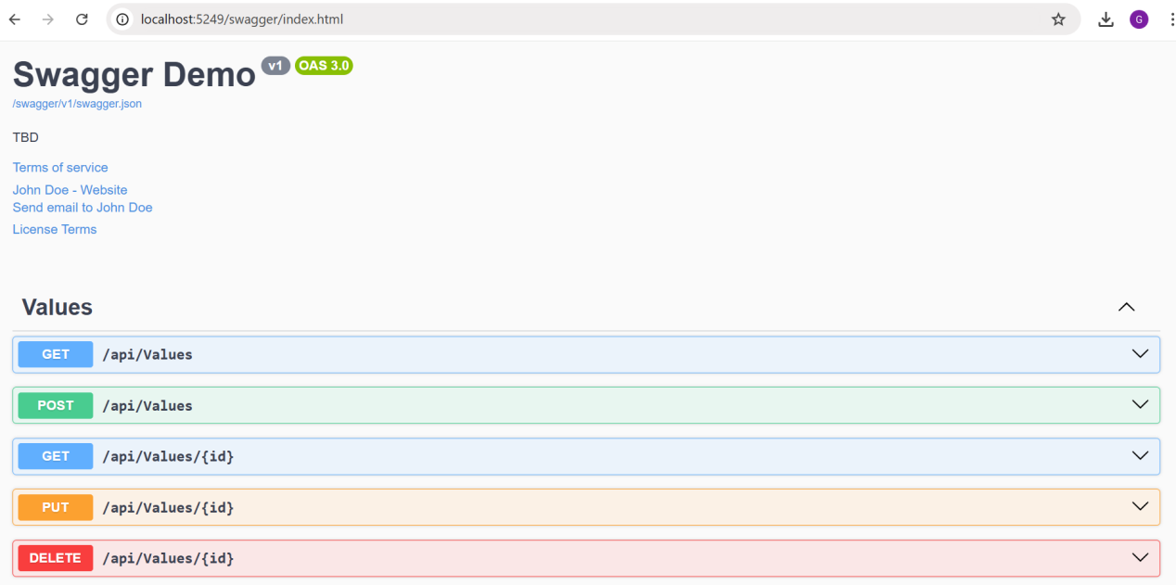

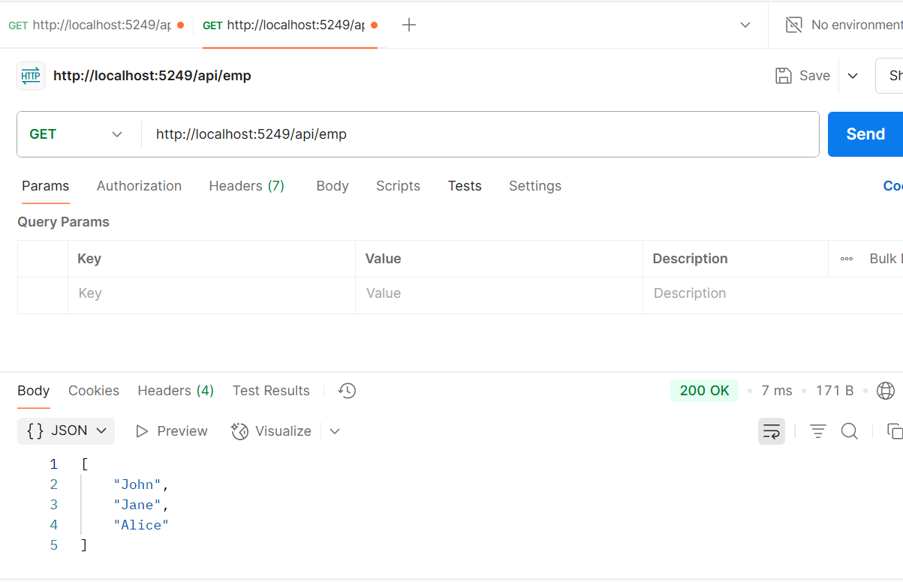
GET /api/emp in Postman:

GET /api/emp/all in Postman:
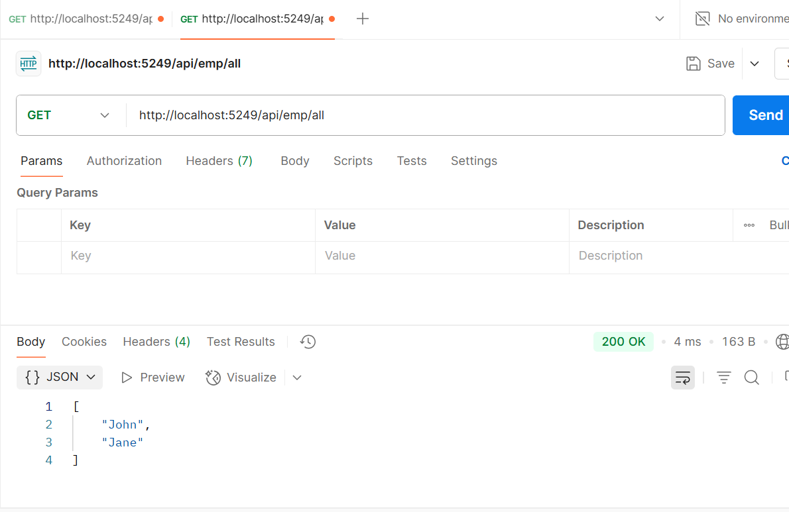

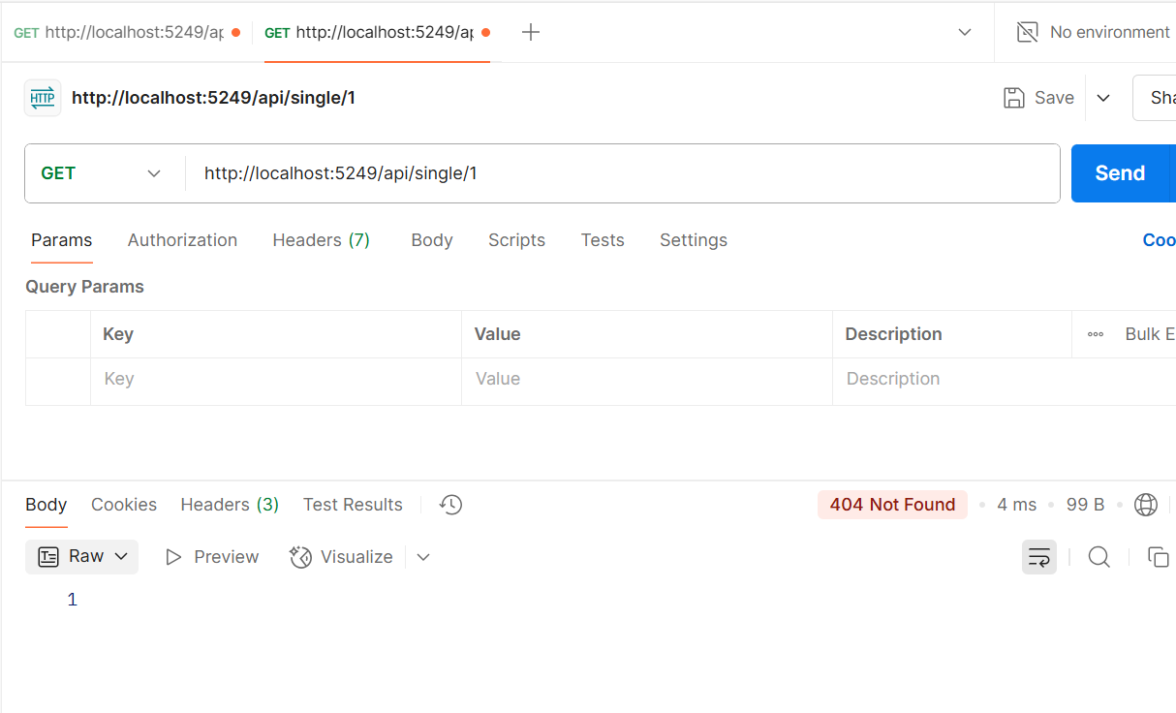
GET /api/emp/single/1 in Postman:

